Greg Solecki
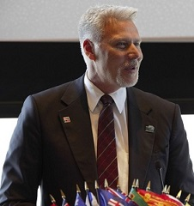
Greg Solecki is one of Canada’s leading experts in disaster and crisis management. He is an internationally Certified Emergency Manager (CEM) and Business Continuity Professional (CBCP) who has been instrumental in the development of international crisis management standards (ISO 22301, ISO 24518, CSA1600), as well as contributing to the development of Canada’s Critical Infrastructure Pandemic Plan as the Water Sector Chair. He has been a guest lecturer at Harvard on crisis management.
With practical experience during SARS, H1N1, H5N1 and President of the International Association of Emergency Managers (IAEM) Canada, he was sought out as a contributing member for the United Nations office of Disaster Risk Reduction (UNDRR) Global Education & Training Institute (GETI).
Greg is also an experienced facilitator and Incident Command System (ICS) 400 instructor for both ICS Canada and the Federal Emergency Management Agency (FEMA) that has worked with every level of response managing Emergency Operation Centre’s during 6 States of Local Emergency, leading to his attendance at Harvard’s National Preparedness Leadership Initiative (NPLI).

